Data and Artificial Intelligence Cyber Shujaa Program
Week 7 Assignment
Regression Models

Student Name: Rodney Roy Gitonga
Student ID: CS-DA03-26025

Contents
Introduction 2
Tasks Completed 2
Step 1: Data Exploration 2
To begin the analysis, the dataset was loaded and examined using the df.describe() function to understand its underlying statistical distribution (such as the mean, minimum, and maximum values for the home areas and prices). An initial scatter plot was also generated to visualize the relationship between the independent variable (area) and the dependent variable (price). As demonstrated in the chart, the data shows a strong positive correlation; this means that as the square footage area of a house increases, its price reliably increases as well. 2
Step 2: Data Preparation 3
Before building the model, the data was separated into features (X) and target labels (y). Using Scikit-learn's train_test_split function, the data was divided into an 80/20 split—meaning 80% of the data was allocated for training the model, and 20% was set aside for testing. This split is standard practice because it ensures the model can be evaluated on unseen data, allowing us to accurately measure how well it generalizes to new inputs rather than just memorizing the data it was trained on. 3
Step 3: Model Training 4
Next, a Linear Regression model was instantiated and fitted to the training data. During this training phase, the algorithm calculated the optimal line of best fit by determining the mathematical relationship between the area and the price. Based on the training data provided, the model calculated a coefficient (slope) of 128.27 and an intercept of 211,542.06. 4
Step 4: Evaluation 5
Once the model was trained, its predictive accuracy was tested on 20% of the data unseen. The model's performance was evaluated using standard regression metrics: Mean Absolute Error (MAE), Mean Squared Error (MSE), Root Mean Squared Error (RMSE), and the R² score. MAE provides the average absolute magnitude of prediction errors. Conversely, MSE and RMSE square the errors before averaging them. Because of this squaring step, RMSE penalizes larger errors much more heavily than MAE, making it a highly effective metric for identifying whether the model's predictions contain any extreme outliers. 5
Step 5: Visualization 5
Conclusion 6

Introduction
This project builds a Simple Linear Regression model to predict the price of a home based entirely on its square footage area.
The dataset contains housing records with areas ranging from 2600 to 4000 square feet.
The corresponding home prices in the dataset range from 550,000 to 725,000.The mathematical foundation of the model is $Y = mX + b$, where $Y$ is the predicted price and $X$ is the area.

Tasks Completed
Step 1: Data Exploration
To begin the analysis, the dataset was loaded and examined using the df.describe() function to understand its underlying statistical distribution (such as the mean, minimum, and maximum values for the home areas and prices). An initial scatter plot was also generated to visualize the relationship between the independent variable (area) and the dependent variable (price). As demonstrated in the chart, the data shows a strong positive correlation; this means that as the square footage area of a house increases, its price reliably increases as well.

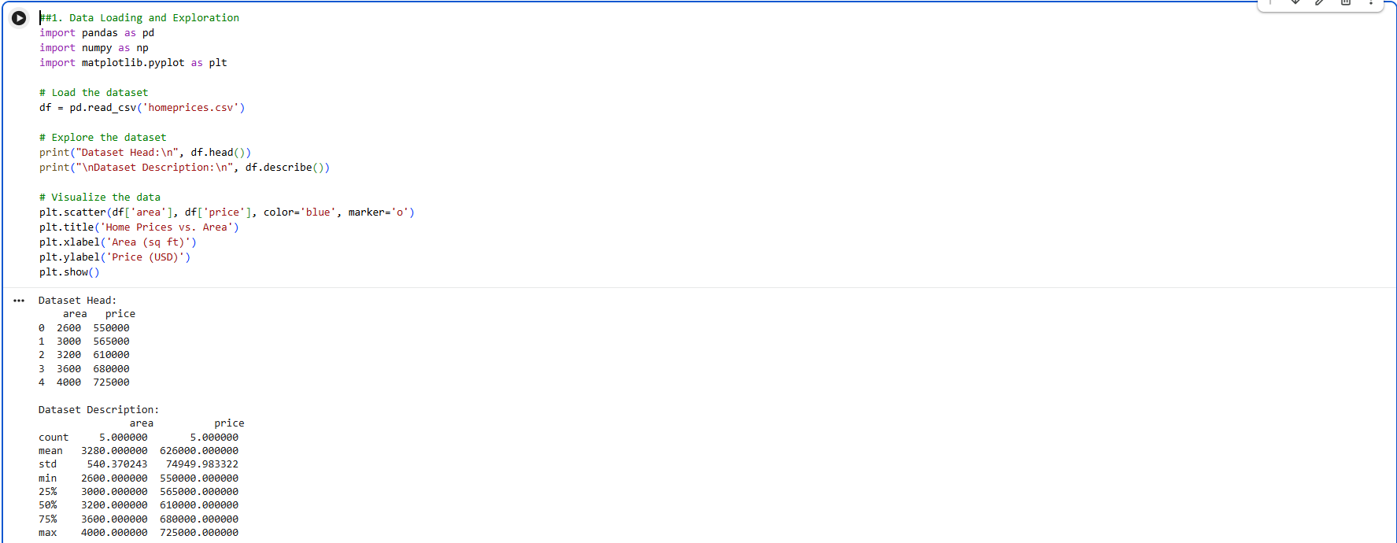

Step 2: Data Preparation
Before building the model, the data was separated into features (X) and target labels (y). Using Scikit-learn's train_test_split function, the data was divided into an 80/20 split—meaning 80% of the data was allocated for training the model, and 20% was set aside for testing. This split is standard practice because it ensures the model can be evaluated on unseen data, allowing us to accurately measure how well it generalizes to new inputs rather than just memorizing the data it was trained on.
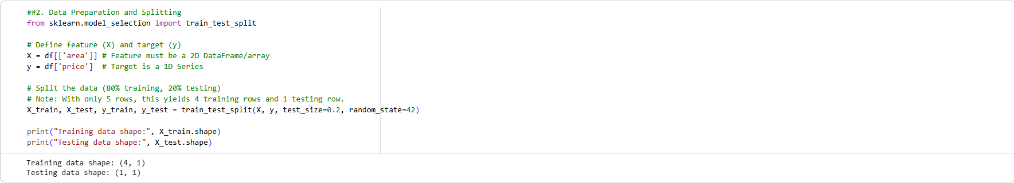

Step 3: Model Training
Next, a Linear Regression model was instantiated and fitted to the training data. During this training phase, the algorithm calculated the optimal line of best fit by determining the mathematical relationship between the area and the price. Based on the training data provided, the model calculated a coefficient (slope) of 128.27 and an intercept of 211,542.06.
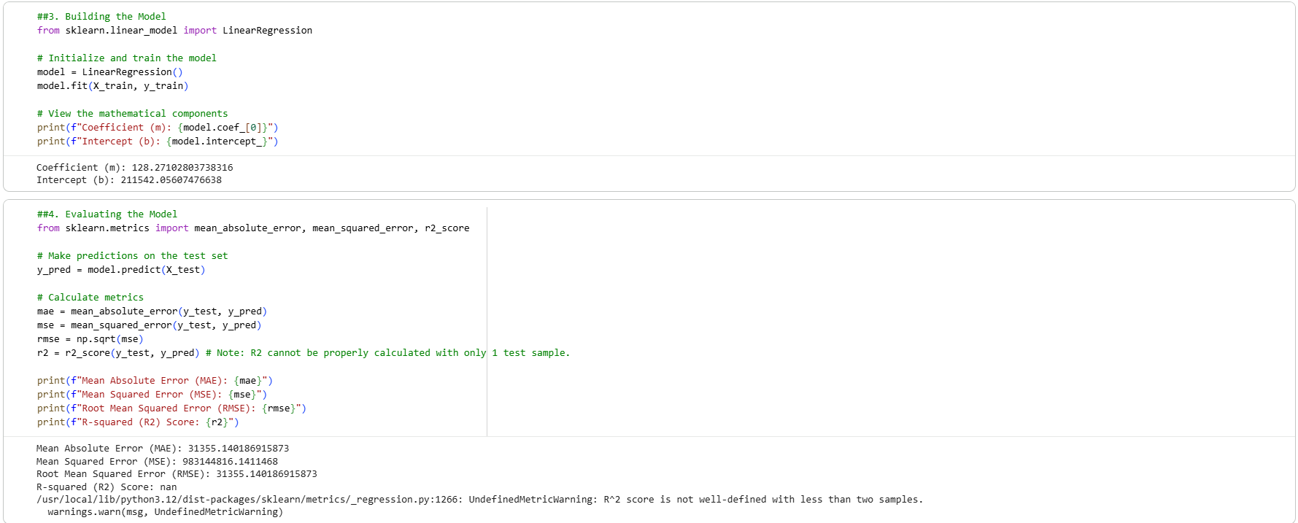

Step 4: Evaluation
Once the model was trained, its predictive accuracy was tested on 20% of the data unseen. The model's performance was evaluated using standard regression metrics: Mean Absolute Error (MAE), Mean Squared Error (MSE), Root Mean Squared Error (RMSE), and the R² score. MAE provides the average absolute magnitude of prediction errors. Conversely, MSE and RMSE square the errors before averaging them. Because of this squaring step, RMSE penalizes larger errors much more heavily than MAE, making it a highly effective metric for identifying whether the model's predictions contain any extreme outliers.
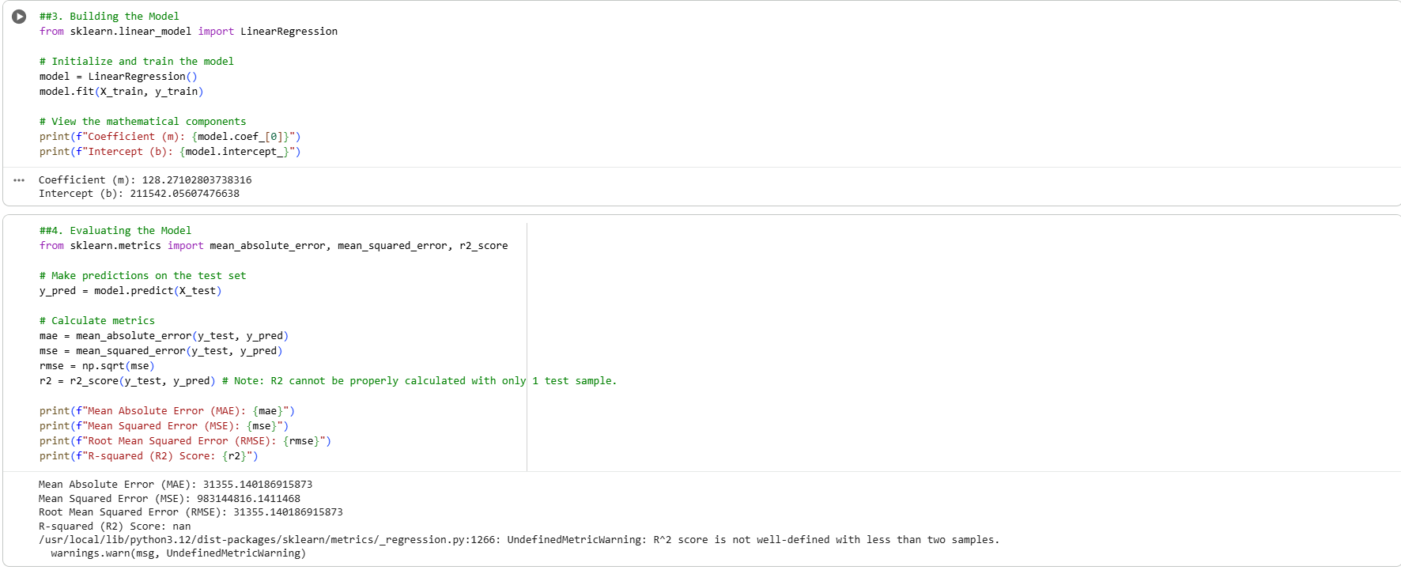

Step 5: Visualization

To visually assess the model's predictive power, the predicted values were plotted alongside the original dataset. In the chart below, the blue data points represent the actual home prices relative to their square footage, while the red line represents the linear regression model's predicted trajectory. The line passes cleanly through the data points, visually confirming the model's ability to capture the dataset's positive correlation.
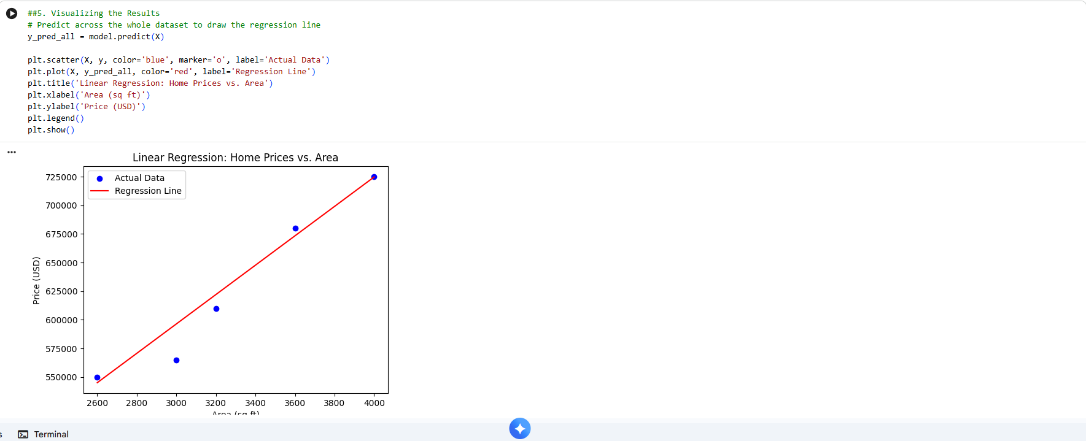
Link to Code:

https://drive.google.com/drive/folders/1fTVtO2kH4Qujz8E_SXug4NG1x0RRoOOK?usp=sharing

Conclusion
Through completing this assignment, I gained practical experience in building a machine learning model from scratch and executing the standard data science pipeline. By exploring the dataset, I learned how to identify and visualize the strong positive correlation between a home's square footage and its market price. Furthermore, training and evaluating the Simple Linear Regression model solidified my understanding of how algorithms calculate the line of best fit and how metrics like RMSE and MAE are used to quantify prediction errors.

